Launch Linux EC2 instances in two regions using a single Terraform file.

**Solution:-**

Installed Terraform in my Ubuntu local Machine

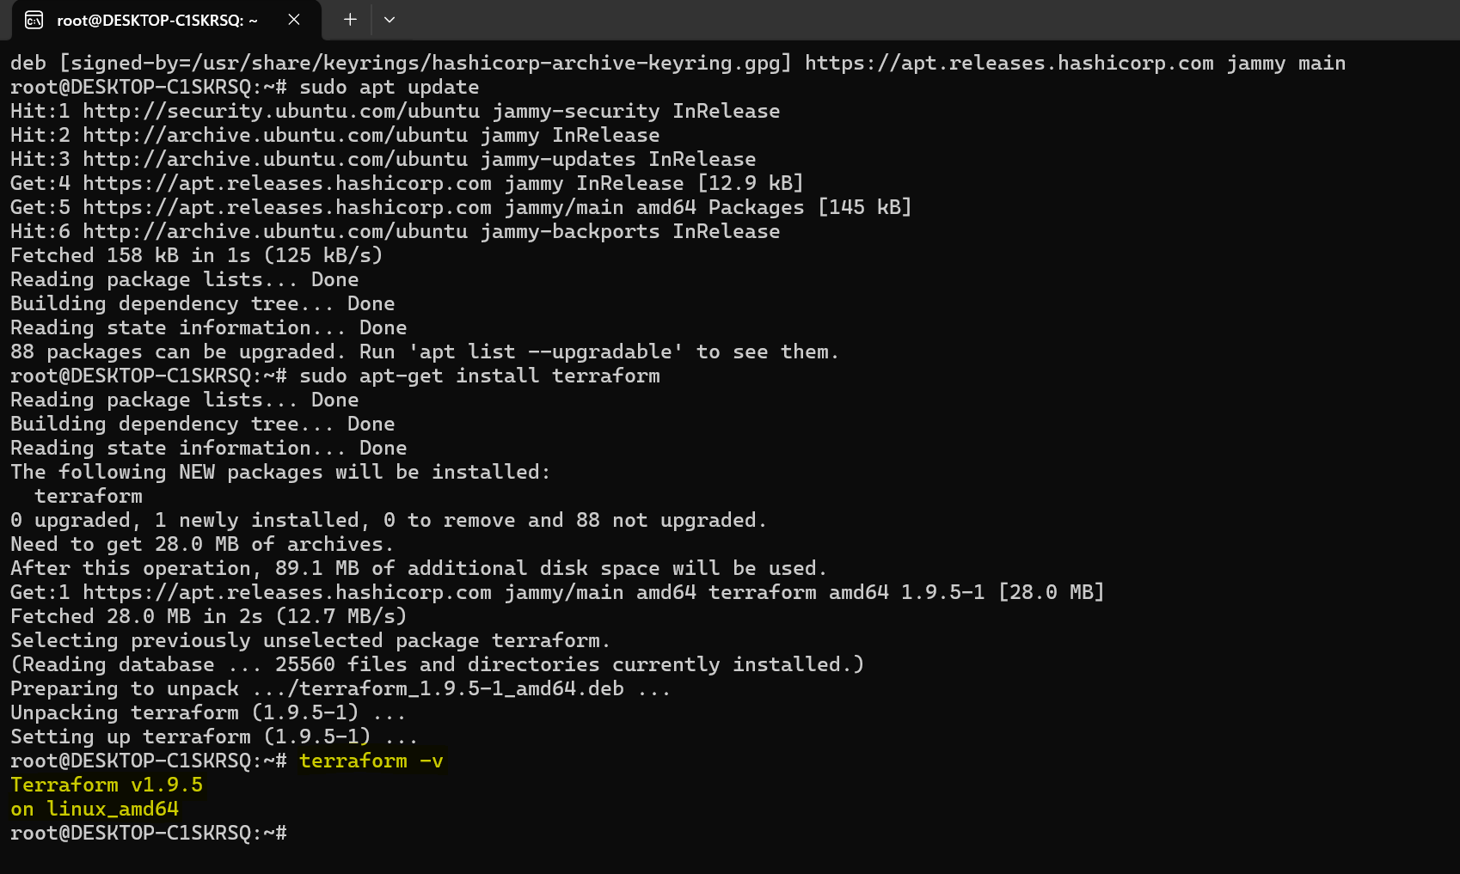

Created main.tf file

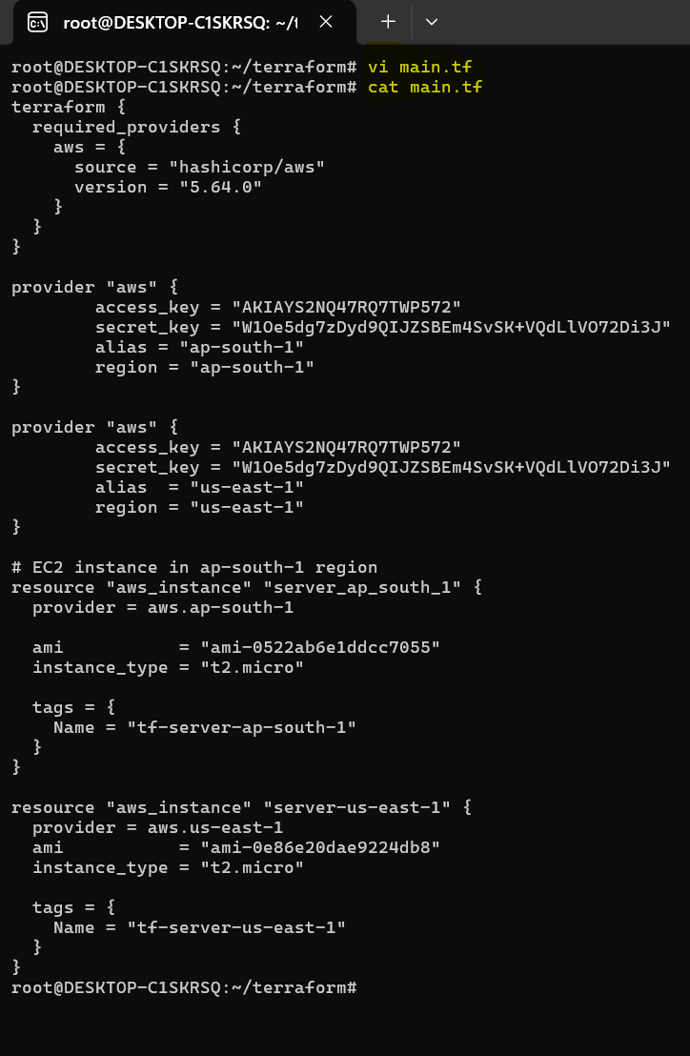

Initialized terraform

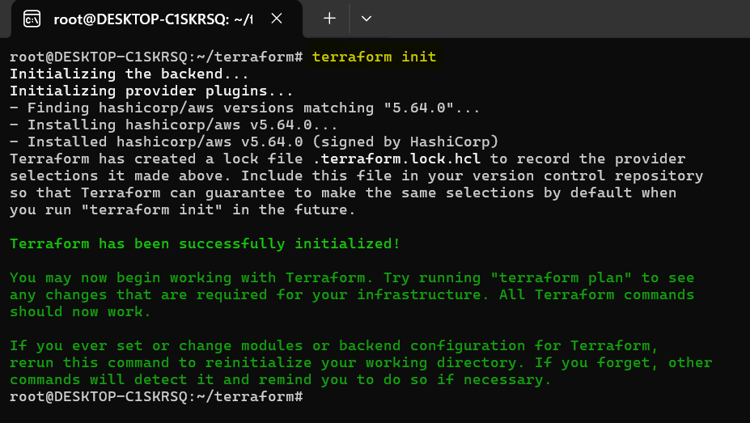

Terraform has been validated successfully

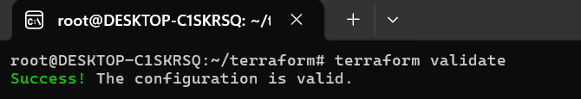

Terraform plan has been completed

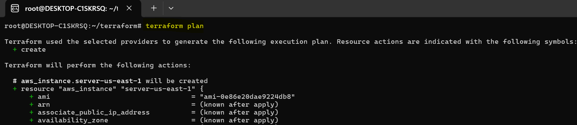

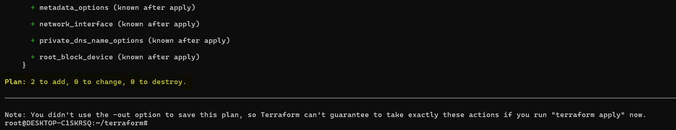

Terraform applied successfully

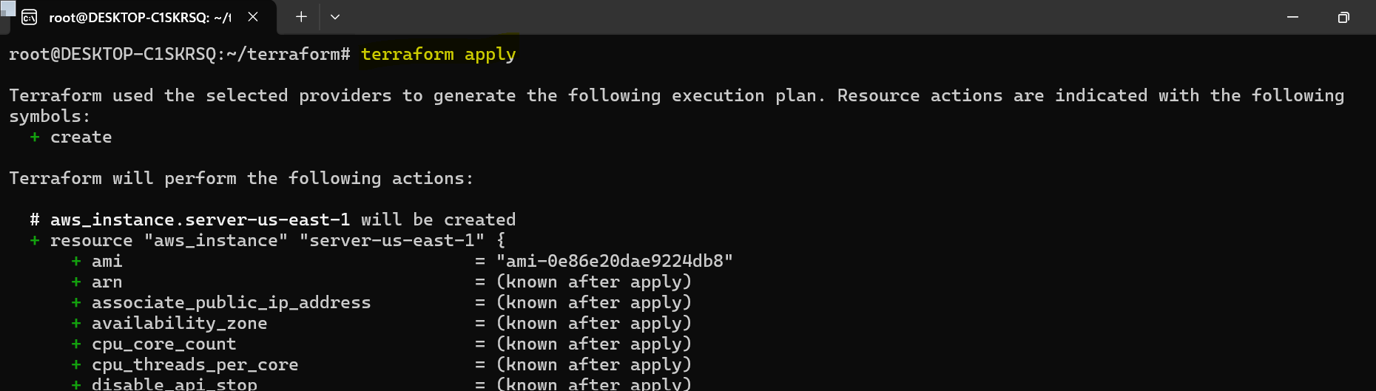

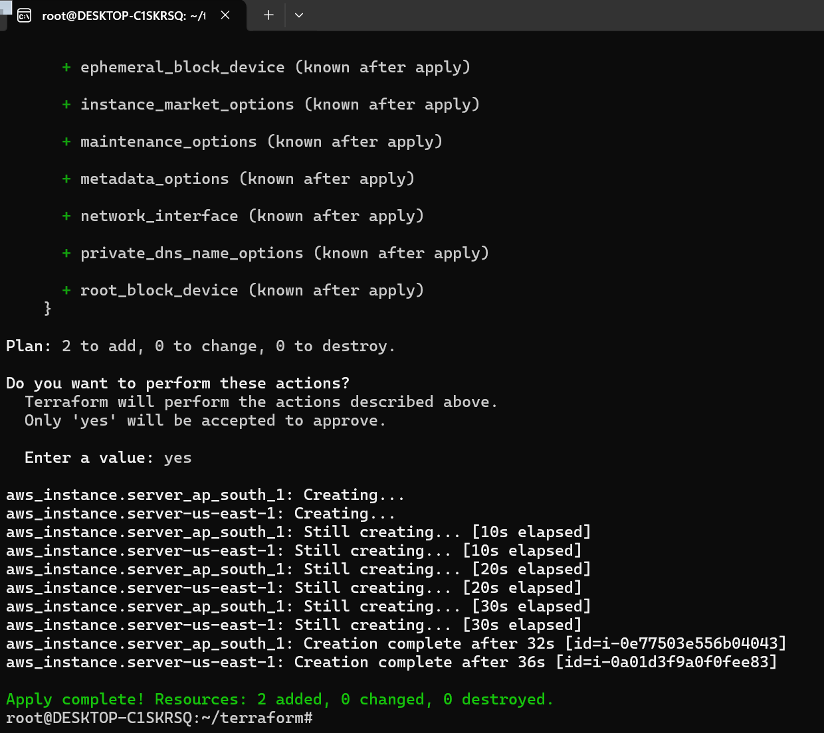

We can able to witness the instance at both the regions

Region - ap-south-1

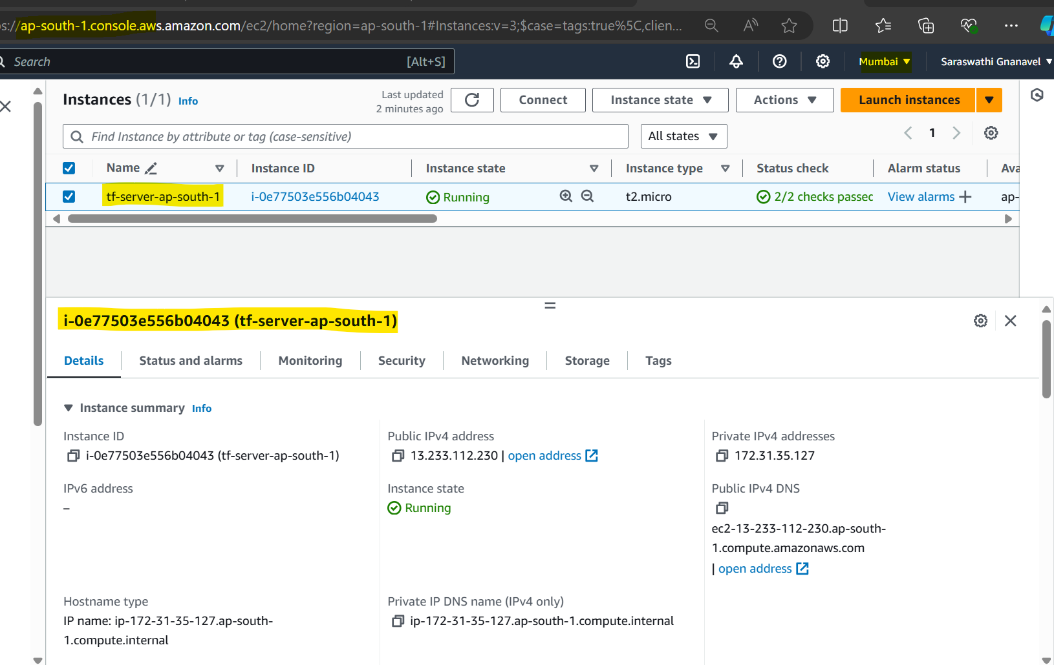

Region – us-east-1

